Done for dataset1 i would say
Check the discussions and questions on kaggle maybe they have some interesting insights

Hyperparameters
1. Naive Bayes
- a. var_smoothing
  - Adds a small constant to each feature’s variance to avoid division by extremely small or zero variances.
  - Higher smoothing → larger variances → flatter Gaussians → model assumes more noise.
  - Lower smoothing → smaller variances → sharper Gaussians → model trusts data more (risk of overfitting).
2. Logistic Regression
- a. C (Inverse Regularization Strength)
  - Controls how strongly weights are shrunk.
  - High C → weak regularization → model fits data closely (risk of overfitting).
  - Low C → strong regularization → simpler, more stable model.
- b. Penalty
  - Defines the type of regularization applied to model weights.
  - L2 → smooth shrinkage; stable; works well with dense numeric data.
  - L1 → drives some weights to zero (sparse model); acts as feature selection.
3. K-Nearest Neighbors (KNN)
- a. n_neighbors
  - Number of neighbors used to classify a sample.
  - Small values → flexible model (risk of overfitting).
  - Large values → smoother decision boundary (risk of underfitting).
- b. Metric
  - Distance measure used to find nearest neighbors.
  - euclidean → straight-line distance.
  - manhattan → more robust to outliers and high-dimensional spaces.
4. Decision Tree
- a. max_depth
  - Maximum allowed depth of the tree.
  - Small depth → simple model (reduced overfitting).
  - Large depth → complex tree (risk of overfitting).
- b. min_samples_split
  - Minimum number of samples required to split a node.
  - Higher values → fewer splits → smoother tree → less overfitting.
5. Multi-Layer Perceptron (MLP)
- a. hidden_layer_sizes
  - Defines the architecture (number of layers and neurons).
  - Larger or deeper networks can learn more complex patterns but risk overfitting.
- b. alpha (Regularization Strength)
  - L2 weight regularization applied during training.
  - High alpha → stronger regularization → more robust model.
  - Low alpha → weak regularization → risk of overfitting.

Dataset1: Traffic accidents
Target variable: crash type

Step1

Task
To clean the data by:
Dropping any missing values, eliminating:
All variables totally empty.
All records having some missing values.
To discard all non-numeric data, eliminating all non-numeric variables.

Data Cleaning & Pre-processing Methodology
- Handling Missing Values:
  - Strict adherence to baseline guidelines: Variables (columns) that were completely empty were dropped.
  - Records (rows) containing any missing values were eliminated to ensure dataset integrity for baseline models.
- Non-Numeric Data Handling:
  - To satisfy the requirement of using only raw numerical data, all non-numeric variables were discarded.
  - Impact: This resulted in the removal of categorical features containing string values (e.g., "Unknown" or descriptive categories), as they were not encoded prior to filtering.
- Target Variable Encoding:
  - The target variable was identified and Label Encoded (0, 1) prior to the numeric filtering step.
  - Rationale: This ensures the target survives the non-numeric purge while remaining in a format suitable for Scikit-Learn models.
Dataset 1 Observations: Traffic Accidents
- Data Retention: * Retained primarily quantitative consequences (e.g., injuries_total, injuries_fatal) and temporal features (crash_hour, day, month).
- Information Loss: * Significant contextual data was lost (e.g., weather_condition, road_defect, crash_cause) because these were text-based.
  - Note: While "Unknown" values can technically represent valid data categories, the columns containing them were non-numeric and therefore discarded per the strict baseline instructions.
How the data changed:
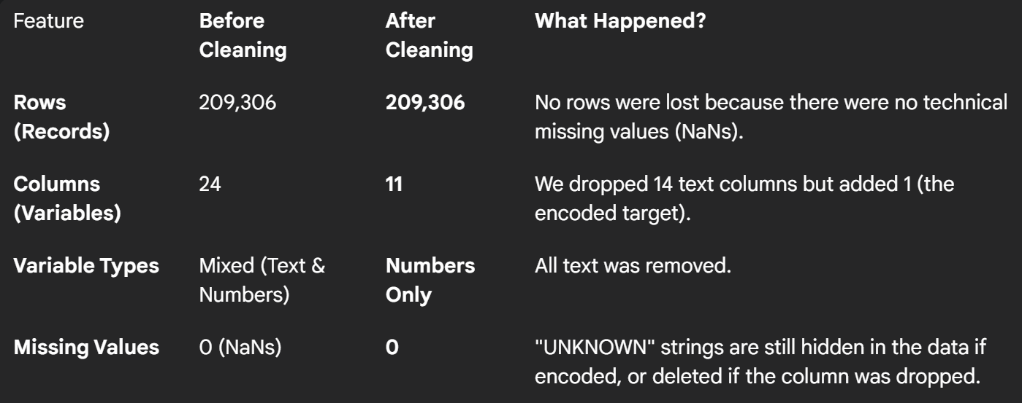

Dataset2: flight stuff
Target variable: cancelled

